QuantifiedSelf App

Modern Application Development - I

R.Vignesh – 21f1002899

**Frameworks Used**

1. Flask for Application Code
2. Jinja2 template + Bootstrap for HTML Generation and Styling
3. SQLite for Data Storage

**Screen Flow :**

1. User Login
2. Dashboard and Trend Lines
3. Tracker Management
4. Tracker Log Events
5. User Login Screen

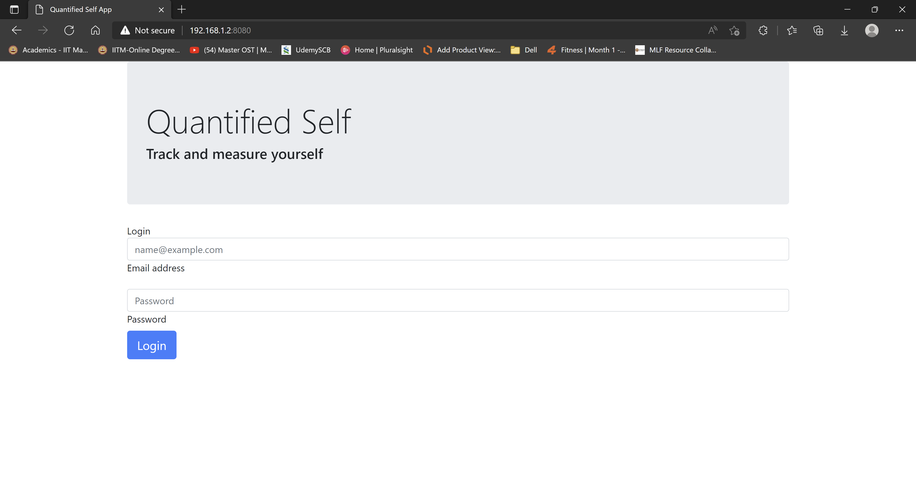

This screen provides login option for user to enter his credentials and authenticated by System

1. User Dash Board Screen

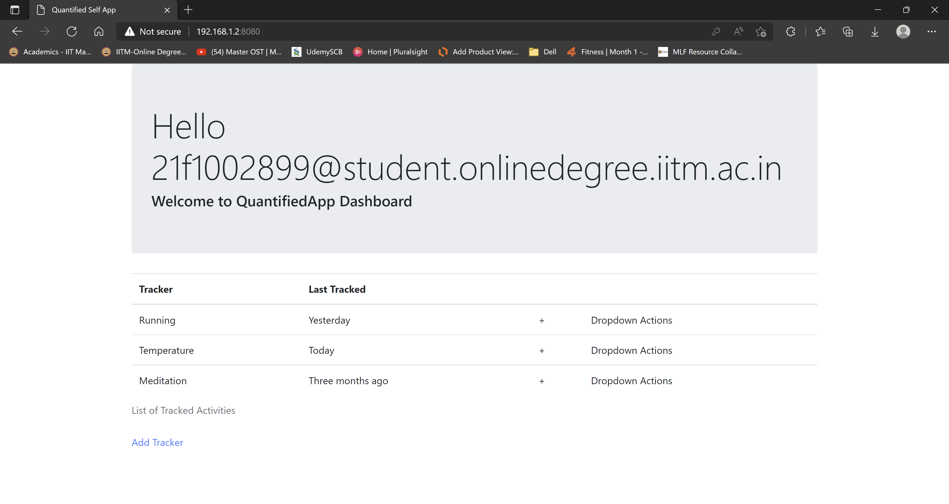

Upon Successful login, the user will be displayed the Dashboard with all active trackers and the status along with an option to edit/delete/add a new Tracker

1. Add New Tracker Screen

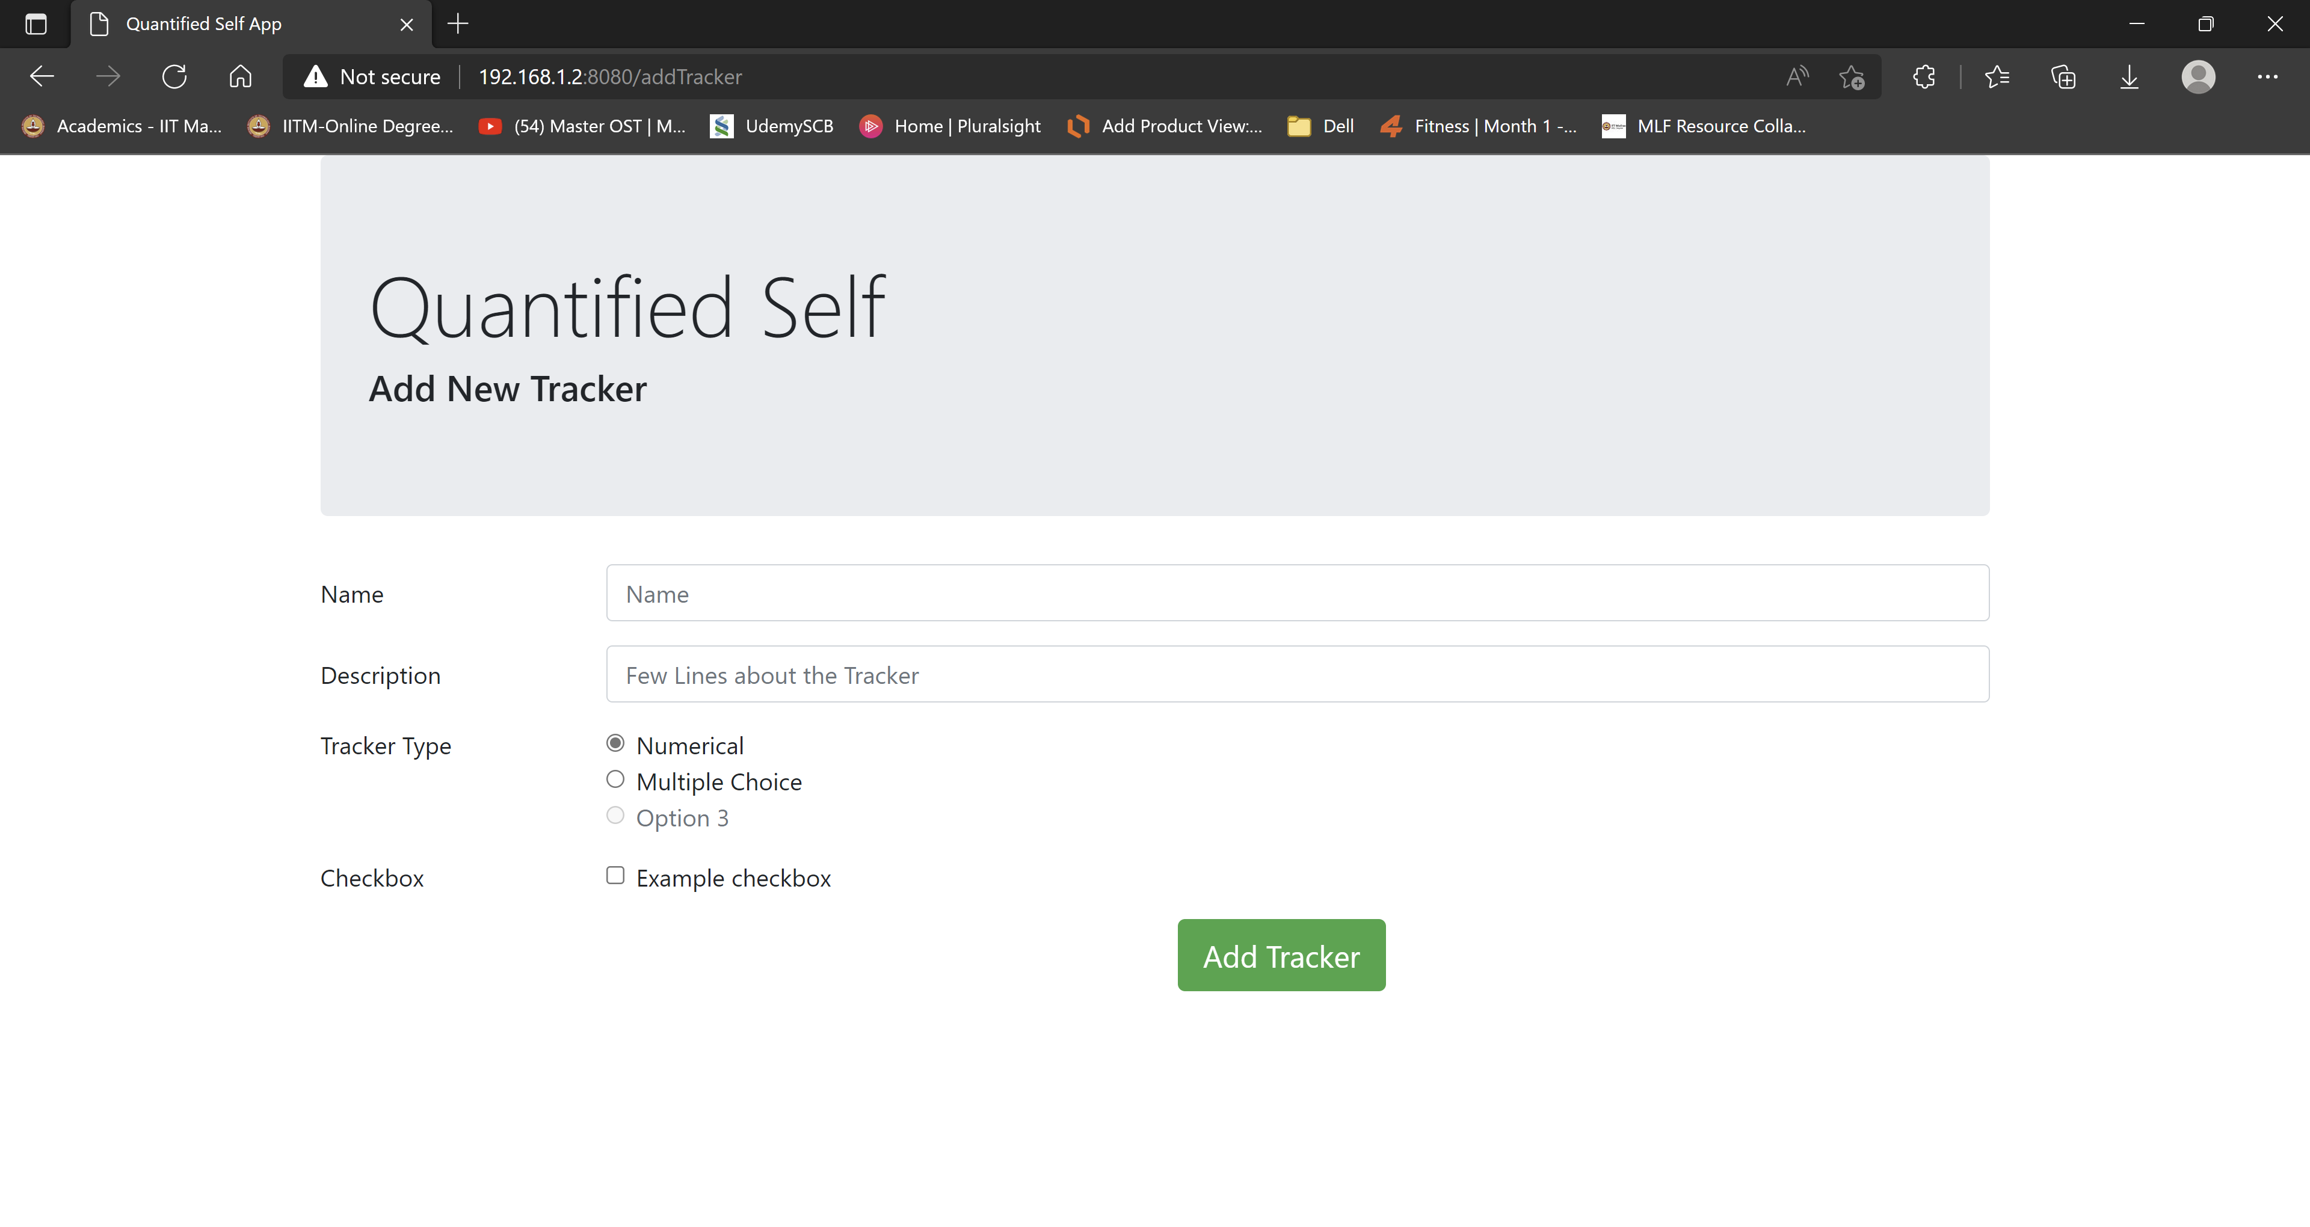

On Click Add Tracker the above page loads which helps create new Tracker with the associated settings for that tracker

1. Log Tracker Screen

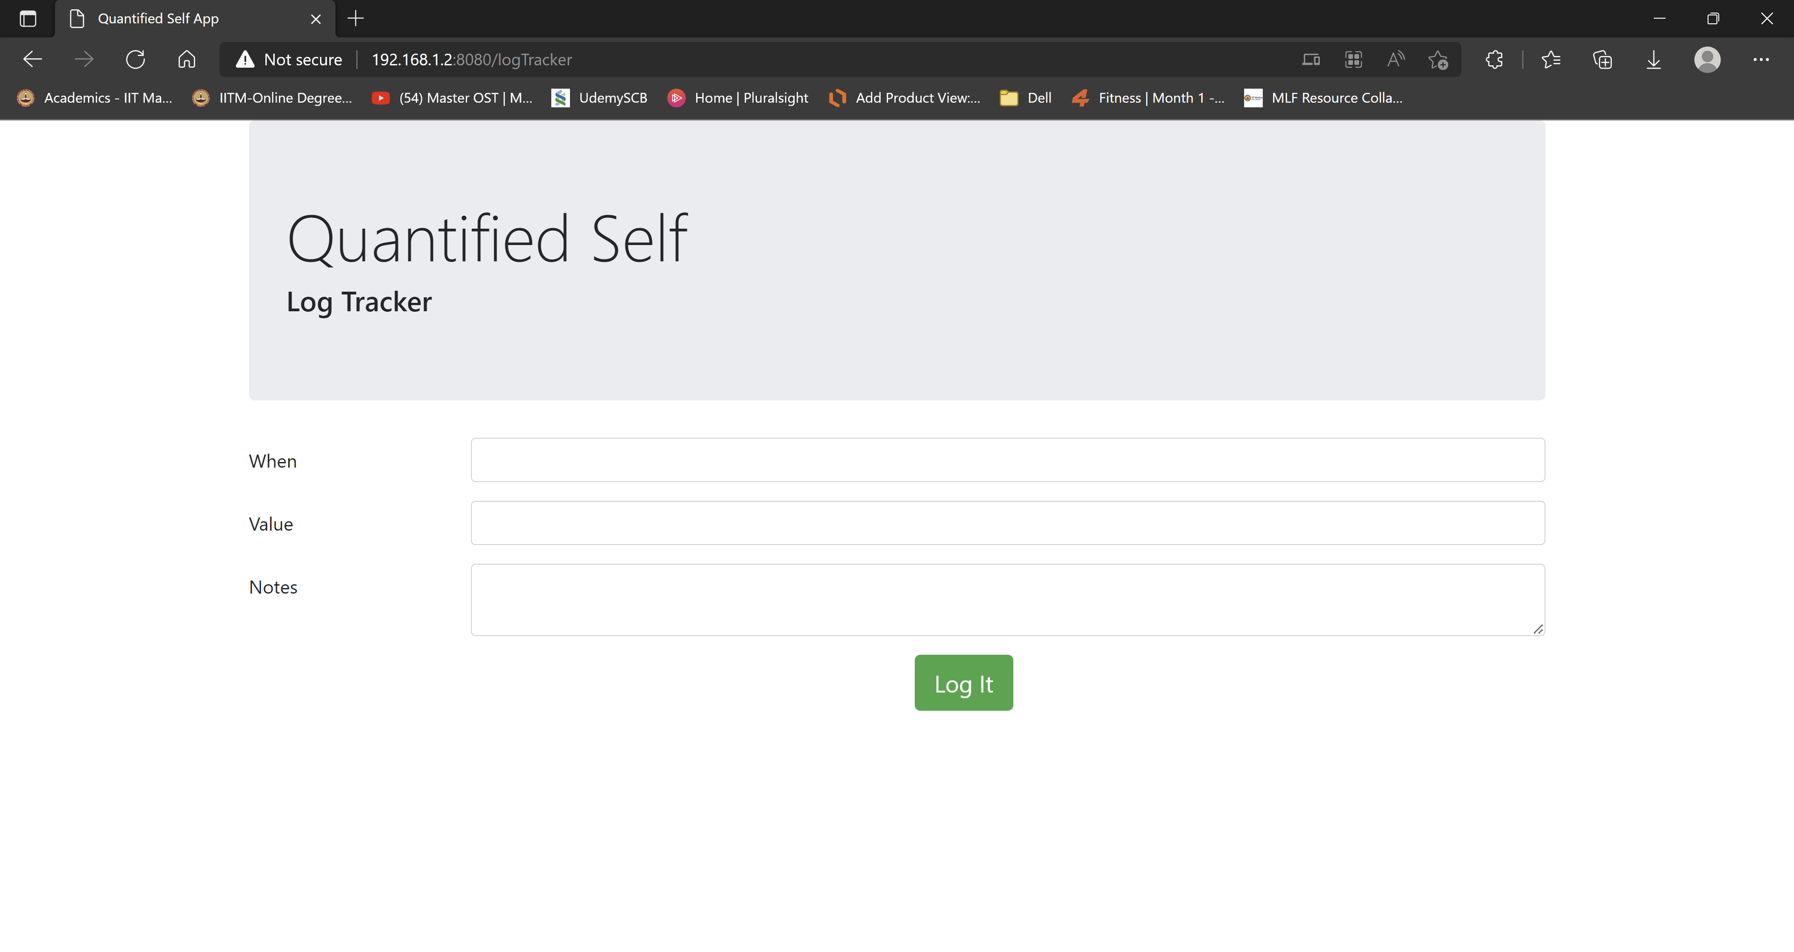

Once the Tracker is added, the above log Tracker screen can be used to log the specific information.